DESIGN

Design difficulties

- How to continously poll the data?
- How to convert data from .csv / .pdf to XML and vice versa?
- How to validate a file?
- How to publish file in Kafka after validation?
- How to subscribe to data from kafka MQ by different service?
- How to convert XML to java object and vice versa.?
- How to update the response folder?
- How to provide user with response.?

Design Diagram -

High Level Design Diagram

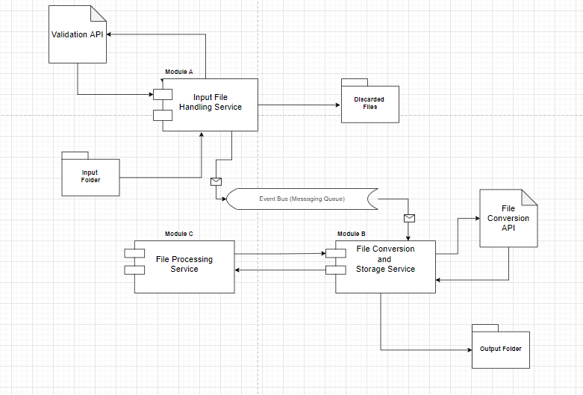

Sequence Diagram

